**Exp No: 5 Date: 21/08/2024**

**PUBLIC CLOUD**

**CREATING AN INSTANCE IN IBM CLOUD**

**AIM:**

Develop a simple application to understand the concept of PAAS using IBM CLOUD.

**PROCEDURE:**

1. In the IBM Cloud console, go to Menu icon Menu icon > VPC Infrastructure > Compute > Virtual server instances.
2. Click Create and enter the information required.
3. Click Create virtual server instance when you are ready to provision

**OUTPUT:**

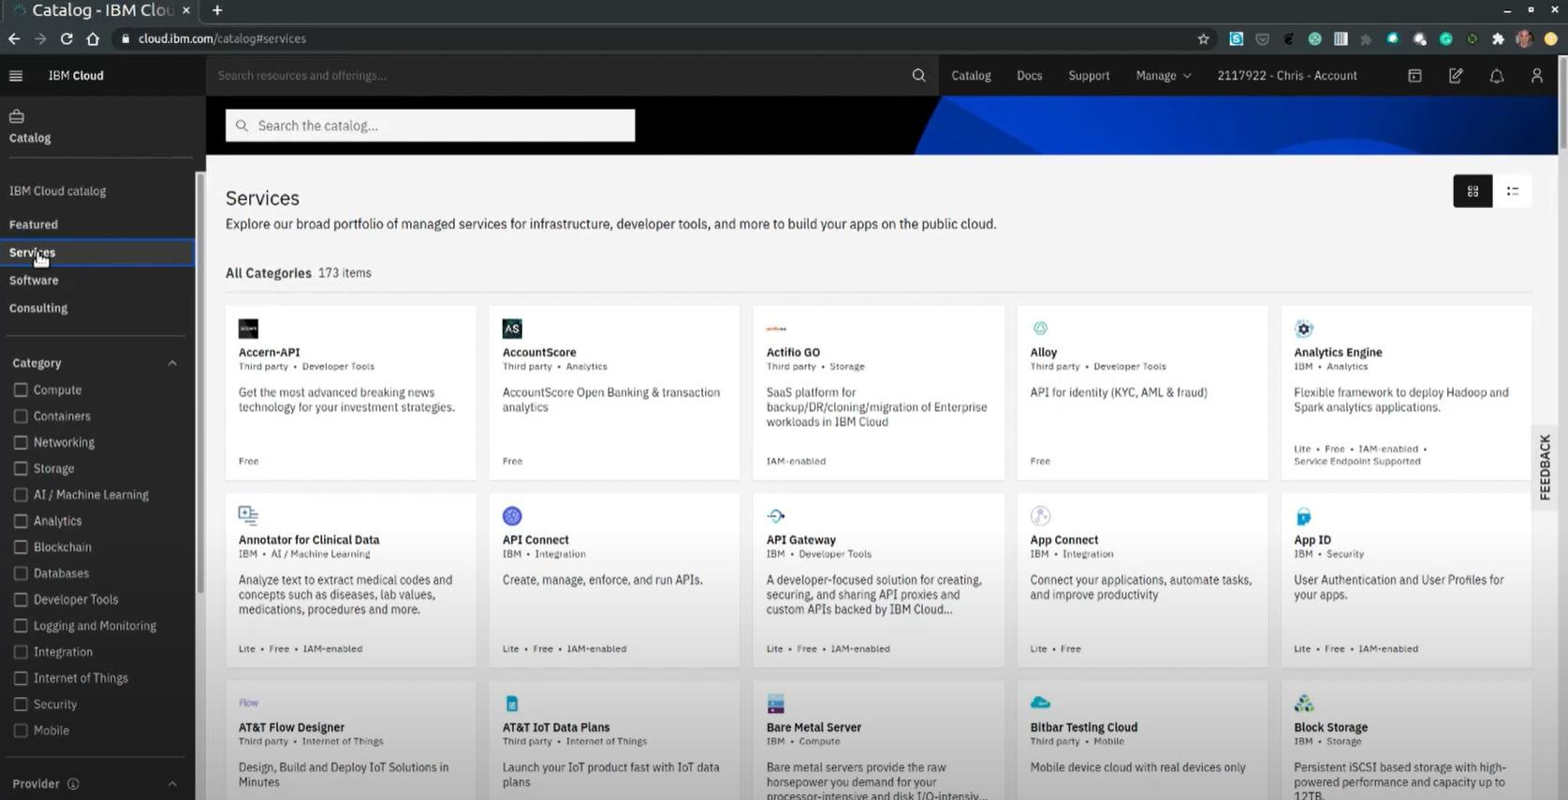

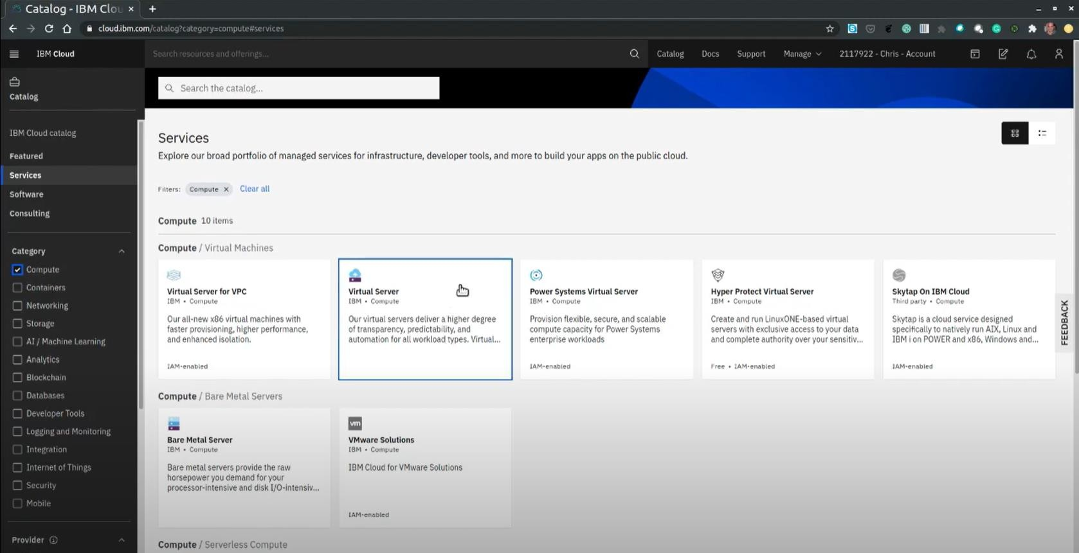

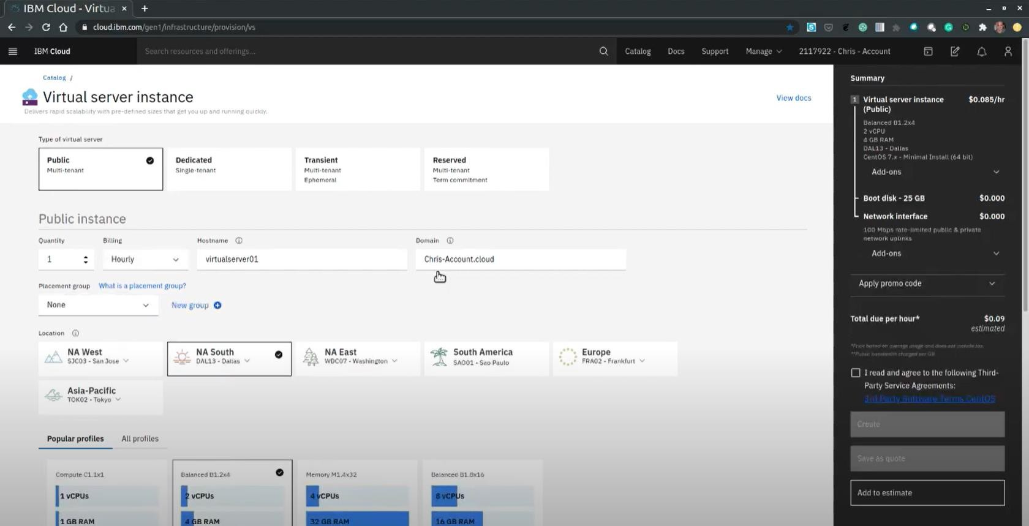

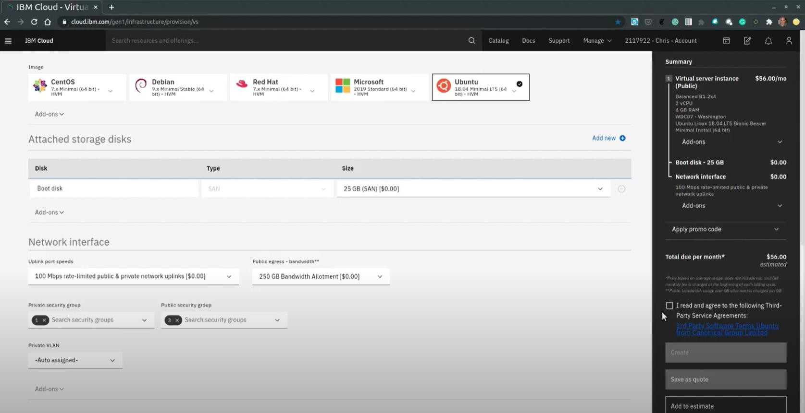

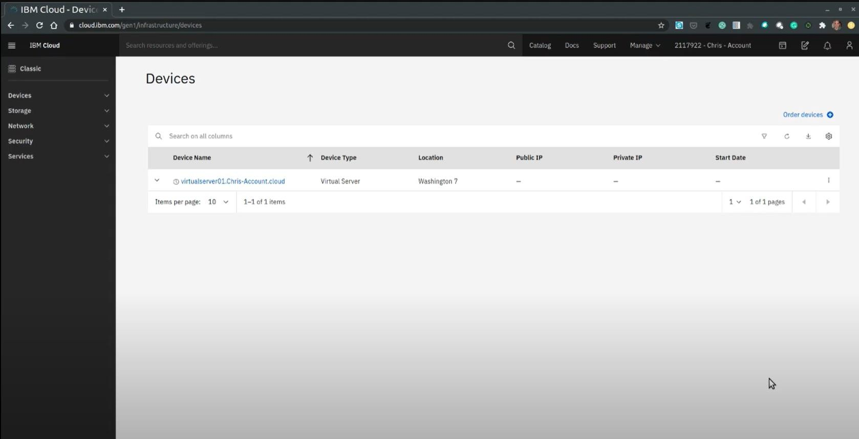

**RESULT:**

Simple application to understand PAAS successfully implemented using IBM CLOUD.